Exercise 1: Implementing the Singleton Pattern
Objective:
To ensure that a logging utility class has only one instance throughout the application lifecycle.
Design Pattern Used:
Singleton Pattern
Classes Used:
- Logger.java
- SingletonTest.java
Explanation:
The Logger class contains a private static instance and a private constructor. The getInstance() method ensures that only one object of Logger is created and reused throughout the application.

Code & Output: Screenshot
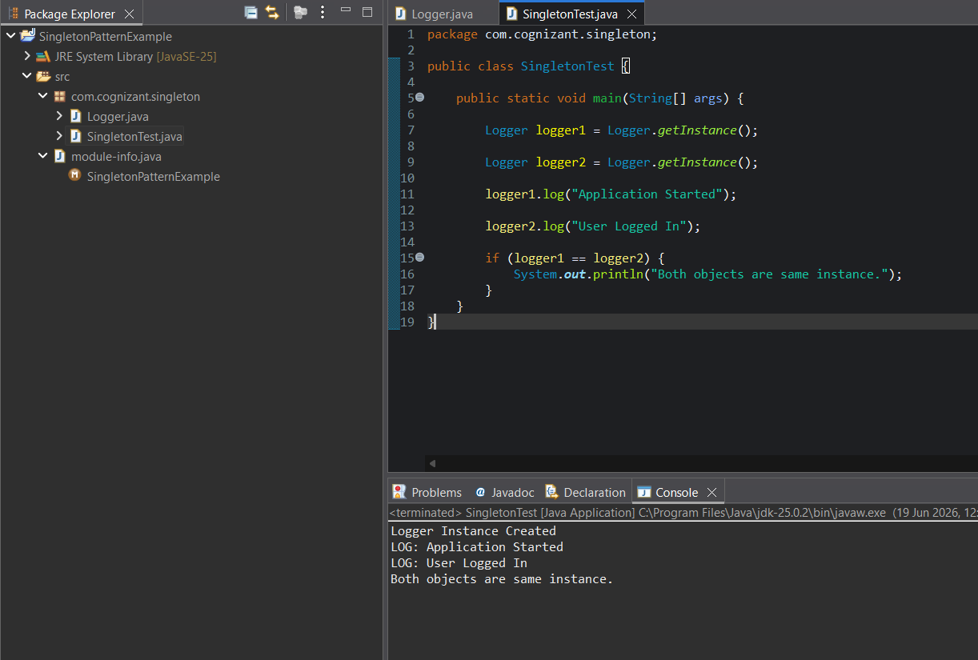

Conclusion:
The Singleton Pattern was successfully implemented and verified.
Exercise 2: Implementing the Factory Method Pattern
Objective:
To create different document types using the Factory Method Pattern.
Classes Used:
- Document.java
- WordDocument.java
- PdfDocument.java
- ExcelDocument.java
- DocumentFactory.java
- WordDocumentFactory.java
- PdfDocumentFactory.java
- ExcelDocumentFactory.java
- FactoryTest.java

Code & Output:
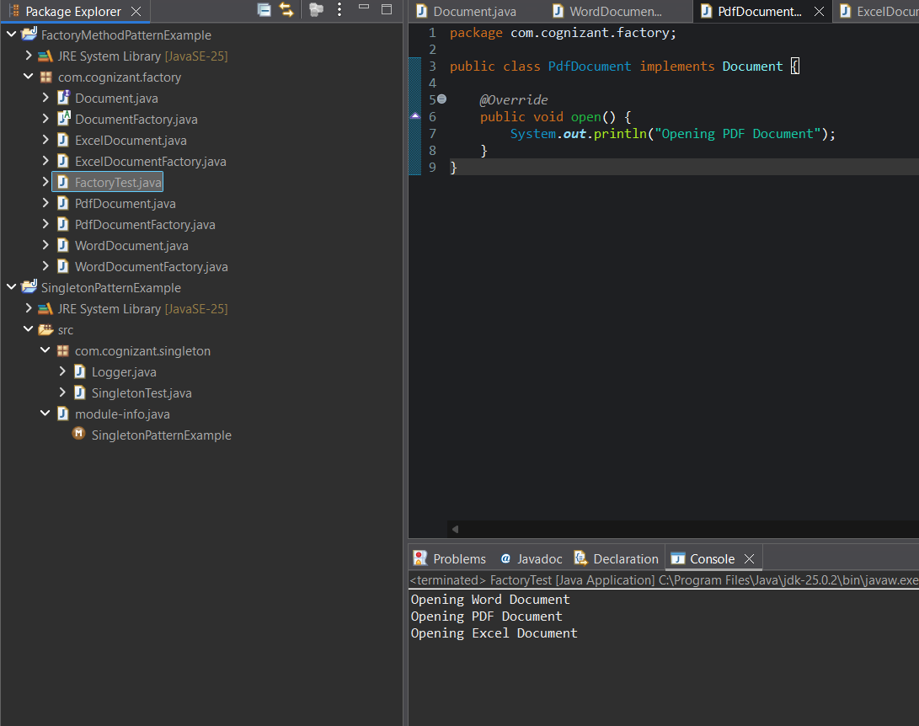
Design Pattern Used:
Factory Method Pattern

Conclusion:
The Factory Method Pattern was successfully implemented. Different document types were created through their respective factory classes.

